How do I schedule an appointment with my advisor?
Virginia Tech is excited to offer online appointment scheduling through the Navigate.
- Go to www.registrar.vt.edu/campus to learn more about the platform and launch the platform by clicking the “Launch Navigate Platform” button.
- Once in the platform you will see a screen similar to this:
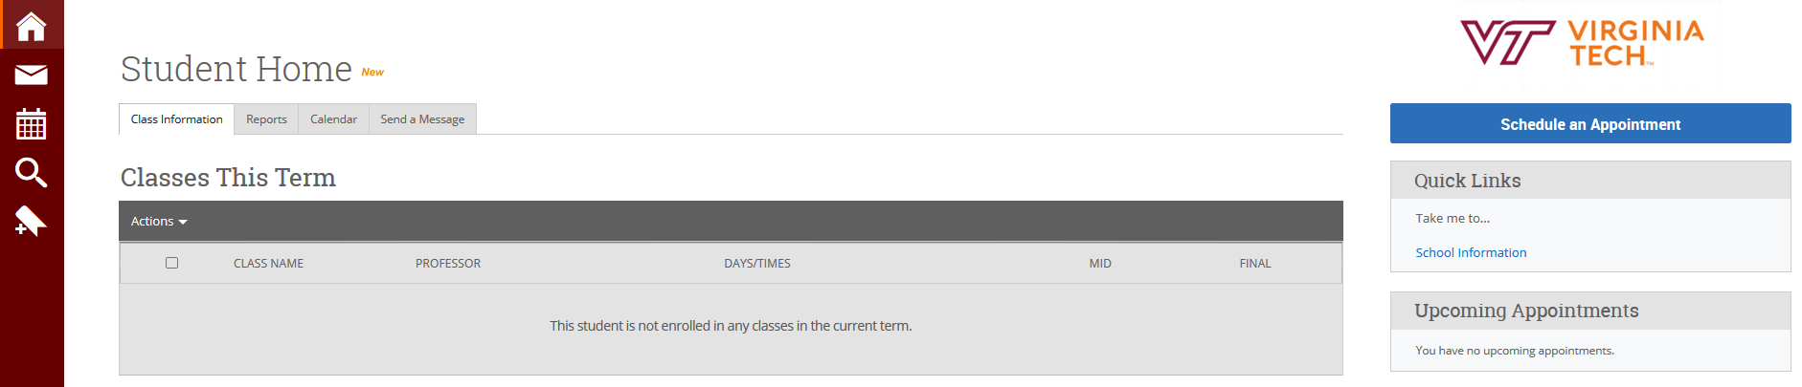

- To schedule an appointment with your advisor, click on Schedule an Appointment.

- Follow the prompts to schedule an advising appointment by first selecting Advising for the type of appointment, then Your College for the Service Category, and finally the major you want advising for as the Service.
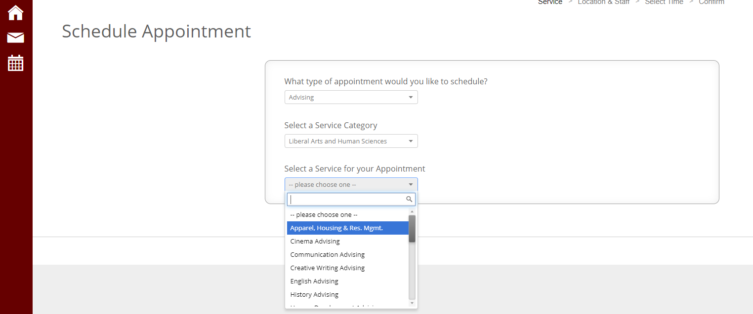

- Then select the location from the drop down menu (this should only list one building location based on the major you selected) and then you can either click Next or select a specific advisor if you are able to in the Select an Advisor box.

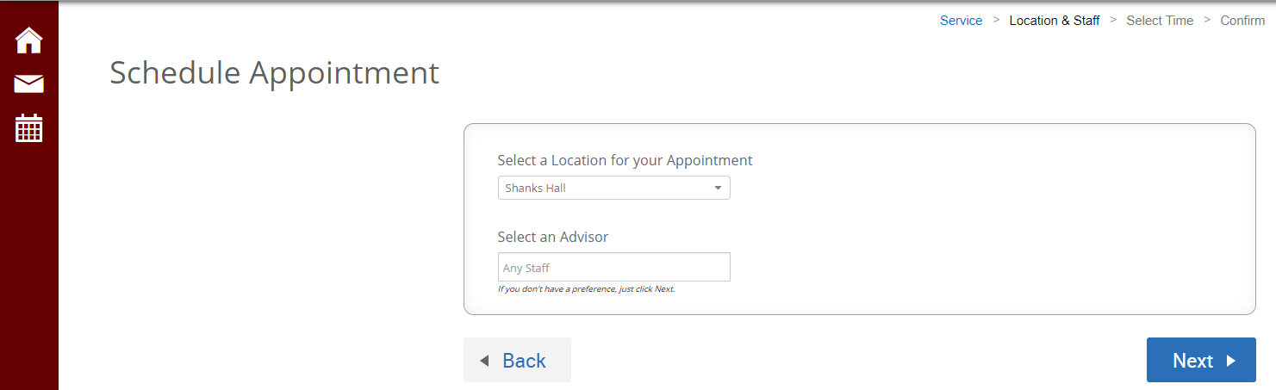

- Then click Next to see the availability options for that advisor.
